Ice Cream Manager [ICM]

Use Case Specification Document

UC10

Modify Presets

Version No. v0.3

Project Document Revision History

|  |  |  |  |
| --- | --- | --- | --- |
| Version | Date | Revision Author | Description of Revision |
| 0.1 | 2016-2-28 | Aly Lakhani | Initial content generation |
| 0.2 | 2016-3-2 | Aly Lakhani | Added introduction, interactions, triggers, pre-conditions, post-conditions, flow of events. |
| 0.3 | 2016-3-6 | Aly Lakhani | Added business rules and assumptions, Added Alternate Flow, Added Use Case Diagram, Added Table of Figures |

Table of Contents

1.0 Introduction 5

2.0 Use Case Information 5

2.1 Actors 5

2.2 Use Case Interaction 5

3.0 Trigger 5

4.0 Pre-condition(s) 5

4.1 UC06 Modify Item 5

5.0 Post-condition(s) 6

5.1 UC01 Modify Inventory 6

5.2 UC03 Modify Route 6

5.3 UC04 Modify Truck 6

6.0 Use Case Activity Diagram 7

7.0 Main/Basic Flow(s) of Events 8

7.1 Stock Depletion Preset Applied 8

8.0 Alternate/Exception Flow of Events 8

8.1 Create Preset 8

8.2 Edit Preset 8

8.3 Delete Preset 8

9.0 Assumptions/Business Rules including Non-Functional Requirements 8

10.0 Use Case Specification Review and Signoff 8

Table of Figures

Diagram 1: Use Case Diagram 1 6

# 1.0 Introduction

The manager will be able to enter custom preferences for inventory levels, and come back to favorited, or most used presets for convenience. This will be an alternate flow from the batch file and/or user entered data. From the presets, the manager will be able to assign inventory levels they have already created anytime they want to modify a truck or route.

# 2.0 Use Case Information

## 2.1 Actors

|  |  |  |
| --- | --- | --- |
| Actor Name | Role | Description |
| Manager | Main | The manager will be the one who creates or chooses presets to be applied to a truck or route |
|  |  |  |
|  |  |  |
|  |  |  |
|  |  |  |

## 2.2 Use Case Interaction

**Predecessors:** Modify Item

**Successors:** Modify Trucks, Modify Inventory, Modify Route

# 3.0 Trigger

* The manager wants to create a new preset
* The manager wants to edit an existing preset
* The manager wants to apply a preset for inventory to a route
* The manager wants to apply a preset for inventory for a truck

# 4.0 Pre-condition(s)

These are the other use cases or other pre-conditions that must be met before this use case can initiate

## 4.1 UC06 Modify Item

As long as the item is made then this use case will be able to create presets of inventory for trucks and routes.

# 5.0 Post-condition(s)

These are the possible output states upon completion of the use case flows.

## 5.1 UC01 Modify Inventory

If the preset is chosen to be applied then the Modify Inventory use case will be able to process the data and set inventory in trucks according to truck or route. This is not a necessary pre-condition in order for the Modify Inventory use case to work; however in order for the preset option to work within that use case, this condition must be met prior to using it.

## 5.2 UC03 Modify Route

The inventory for the specified route will be set to the chosen preset.

## 5.3 UC04 Modify Truck

The inventory for the specified truck will be set to the chosen preset.

# 6.0 Use Case Activity Diagram

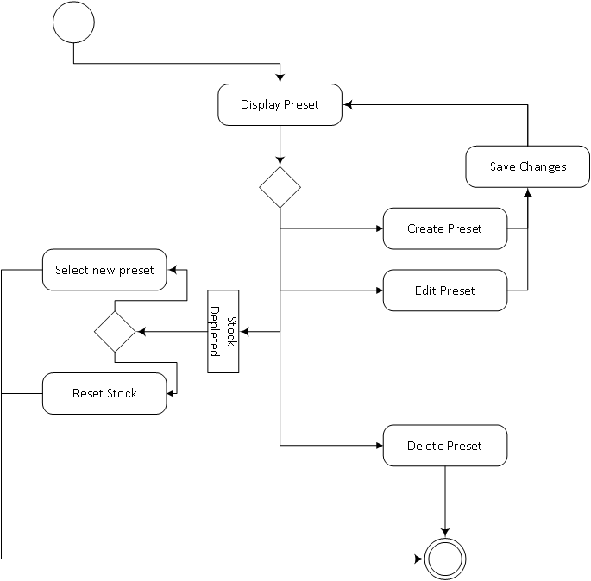

Diagram 1: Use Case Diagram

# 7.0 Main/Basic Flow(s) of Events

## 7.1 Stock Depletion Preset Applied

1. The manager enters custom preferences for inventory levels and saves it.

2. The stock is depleted.

3. The manager will be able to select one of the presets they already have created and apply that.

4. They can also press the refresh stock button and reload the last used inventory levels for the selected truck.

5. The inventories are modified for the truck.

# 8.0 Alternate/Exception Flow of Events

## 8.1 Create Preset

1. The manager is able to create a preset that will by default be blank. They will set their own presets.

2. The manager will click “Save changes”, and the changes will be available for viewing.

## 8.2 Edit Preset

1. The manager will be able to go back into the created preset and alter the values they initially entered.

2. The manager will click “Save changes”, and the changes will be available for viewing.

## 8.3 Delete Preset

The manager can select a preset and delete it. Doing this means the preset will not be available for future use.

# 9.0 Assumptions/Business Rules including Non-Functional Requirements

UC10-1. Modifying a preset and or applying it should be processed within 1 second, or provide a progress bar otherwise

UC10-2. We will not be providing any presets, the manager will have to create them all

# 10.0 Use Case Specification Review and Signoff

Review and Signoff of the Use Case Specification

|  |  |  |  |
| --- | --- | --- | --- |
| Name | Project Team Role | Signature | Date |
| Camille Williams | Project Manager |  |  |
| Marc King | Team Lead |  |  |
|  |  |  |  |